How to EFile Complaints

Version 1.1

September 1, 2015

Don Bellenger

[donald.bellenger@gmail.com](mailto:donald.bellenger@gmail.com)

240-426-1589

EFile Complaints – Version 1.1

**Table of Contents**

Introduction 3

Cleaning out old files from the last run 4

Scanning Signed Complaints to the Z: Drive, and Copying the Files 6

Using the LTPROD-Access application to make a Helper Excel File 8

Step A – Renaming Signed Files 14

Connect to EFile Express in the Internet Explorer Web Browser 20

Step B – Efile the Named Complaints 22

# Introduction

These step-by-step instructions are written for “Cathy”. Modify for use in your own environment.

This describes a procedure for EFiling a Complaint Form (“complaint”), once the form has been signed by the plaintiff attorney (e.g. Kevin McParland). This EFiling procedure is part of a wider set of set of applications for producing complaints, which includes LTWeb for entering the data for the complaints. That data is entered by BBSG (“Firm”) personnel, or by the Firm’s clients themselves.

There is occasionally a reference in this document to TeamViewer, which is software that enables you to work from home, as if you are sitting at your computer at work. When using TeamViewer, the receipts you produce will print at the office, unless you set up remote printing to print Receipts at home.

There are these parts to EFiling Complaints:

* Cleaning out old files from the last Efile complaintsrun
* Scan signed comlaints to the Z: Drive, , and copy those files to the EFile environment
* Use **LTWeb** to make a **Helper Excel file**
* Step A - Rename Signed Files
* Connect to EFile Express in the Internet Explorer Web Browser
* Step B – Efile the Named Complaints

# Clean out old files from the last run

* Use **Windows Explorer**. You can get to Windows Explorer from the “Windows Start Menu” you see when clicking the **Start Button** (shaped like the earth, with a Microsoft flag covering it) on the lower left of your Desktop

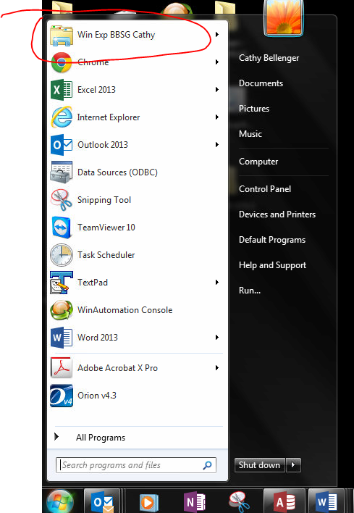

* Delete all the files in these directories
* F:\CATHY EFILE 2\SingleTargetFile
* F:\CATHY EFILE 2\Step 1 – Signed Complaints
* F:\CATHY EFILE 2\Step 1 Backup – Signed Complaints That Were Renamed
* F:\CATHY EFILE 2\Step 2 – Named Complaints
* F:\CATHY EFILE 2\Step 3 – Complaints That Were EFiled

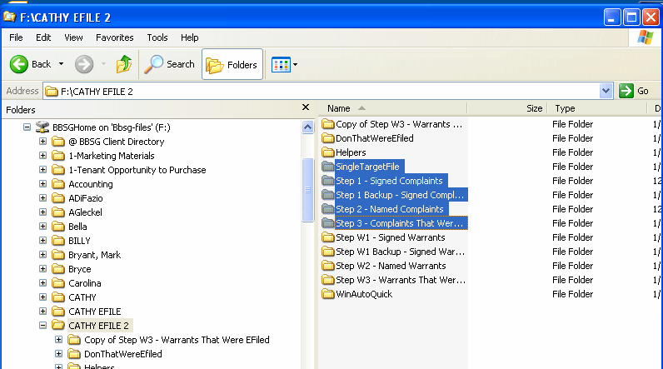

# Scan signed complaints to the Z: Drive, and copy the files to the Efile environment

* Scan each signed Complaint into Z:\cathy
* Remember the date and time when you did the scan
* Go to Z:\cathy in Windows Explorer
* IF you don’t see the “Date Modified” column, click the icon way to the right of “New Folder”, and select “Detail”

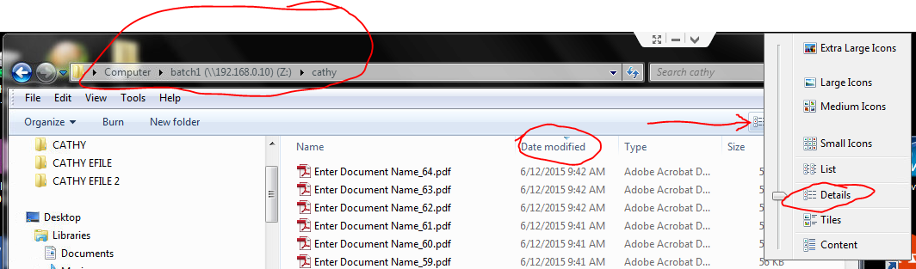

* Select the complaint files for one property. **You can only Efile for one property at a time**. You can look at Date Modified to see if you have the right files. To select the group of files to copy:
* EITHER use the mouse and shift key
* OR click on the first file, hold the shift key, and hit the down arrow until you get to the last file

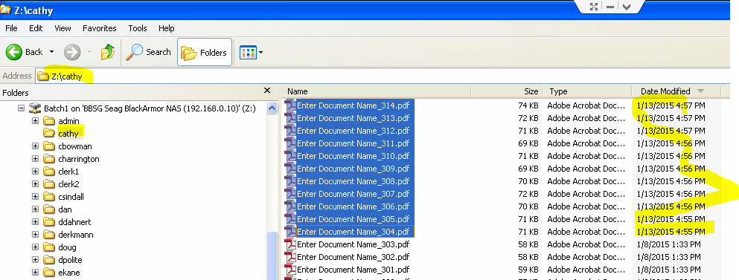

* Press ctrl-C to copy the files.
* Navigate to F:\CATHY EFILE 2\Step 1 – Signed Complaints
* Press ctrl-V to paste the files.
* Right-click on the F:\CATHY EFILE 2\Step 1 – Signed Complaints folder, select Properties, and note the number of files. For example, in the picture below, there are 271 complaints to EFile.

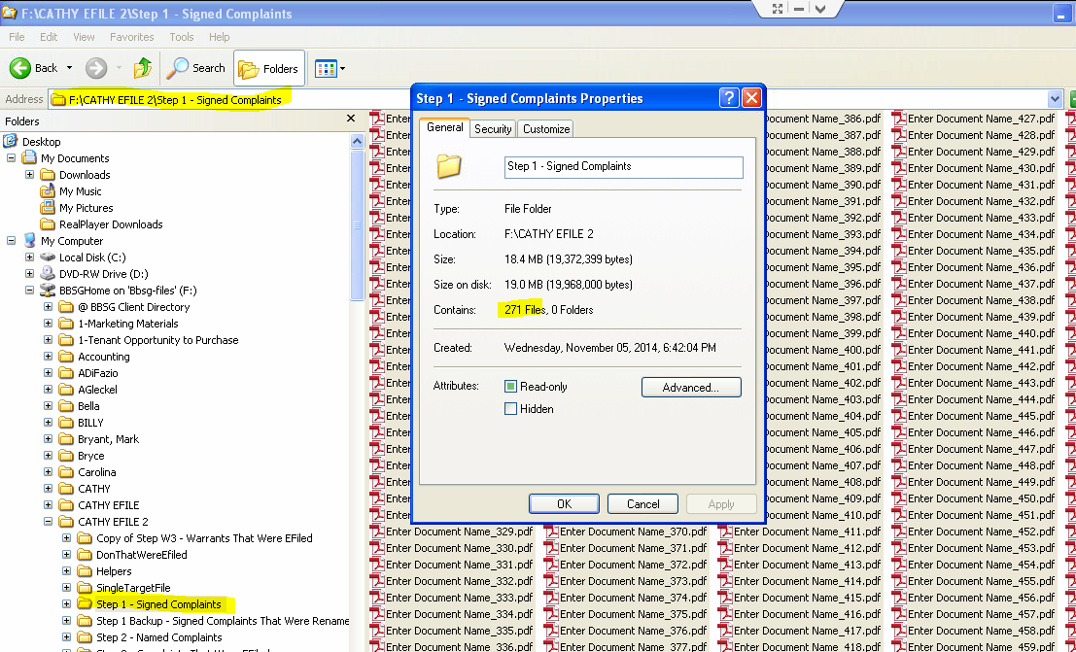

# Use LTWeb to make an Excel Helper File

* Go to the Chrome browser
* Start the LTWeb application, and log in 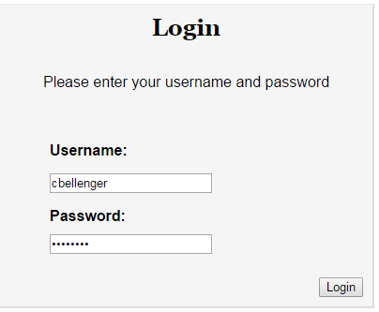
* Select the correct Client, Property, and Filing to match the set of warrants you are EFiling. Start with client, search, and click on the record so that the Edit and Delete buttons are enabled.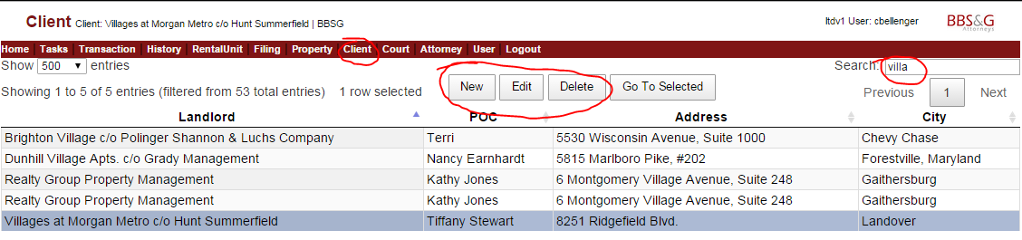

Select property, and click on the property

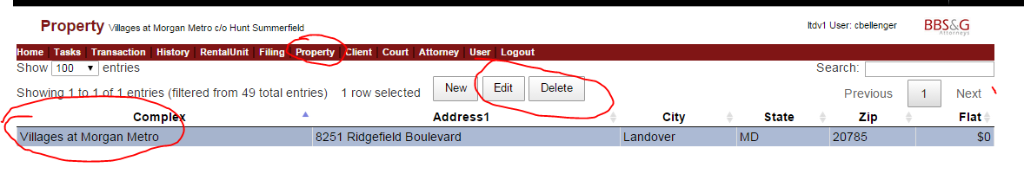

Select Filing, and click on the Filing with the complaints

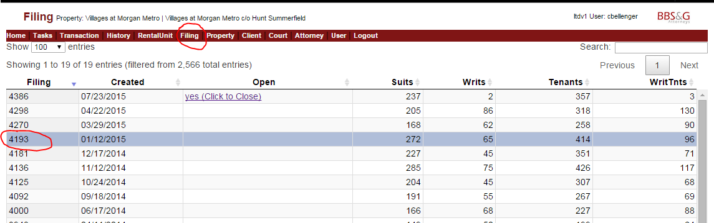

Select Tasks, and click Calculate Absolutes, and then Calculate Filing Statistics, and then Make Excel Helper for EFiling Complaints.

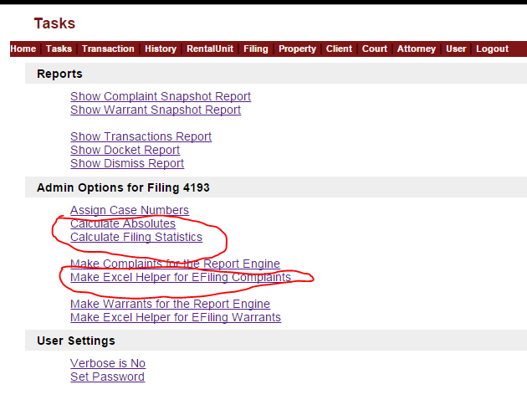

LTWeb will make a Destination File Name for the Excel Helper file, based on the date and time the file was generated, the Client, and the Filing. Just accept it, and click Go.

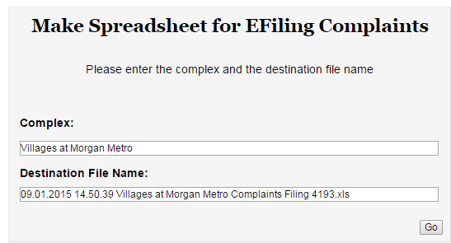

The Excel file will be downloaded to your Browser’s download area.

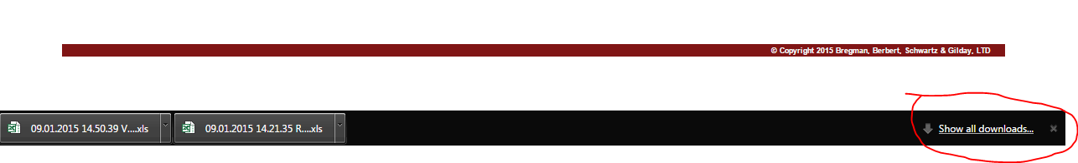

Move that file from the download area to the EFiling environment by clicking on Show All Downloads, then click on Show in Folder on the correct file.

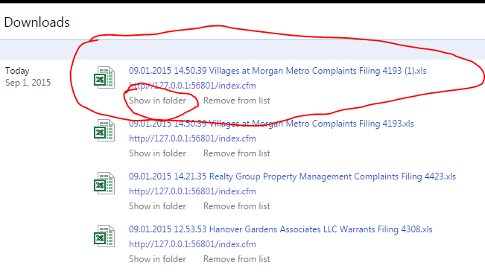

Then right-click on the correct file (based on name, and date the file was created).

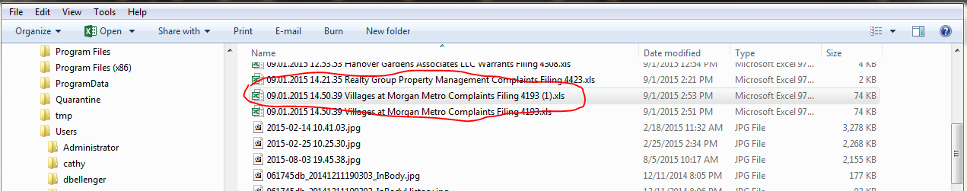

Select copy, then navigate to your Helper area, right click, and select Paste. The result is shown below. Take the time to delete any older helper files from that directory, to prevent confusion.

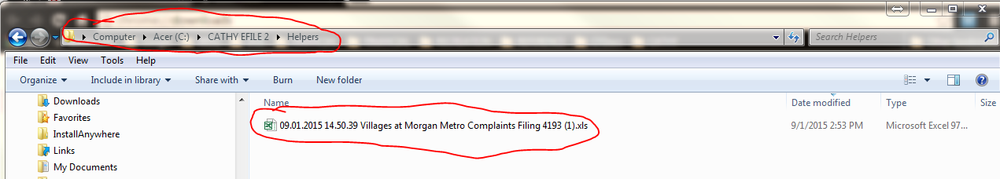

# Step A – Rename Signed Files

* Go to your Desktop. Use the Windows key at the bottom right of your **Windows Taskbar** at the bottom of your screen to do this (may be hard to see). When you are “on your desktop”, you will see the icons you have put there.

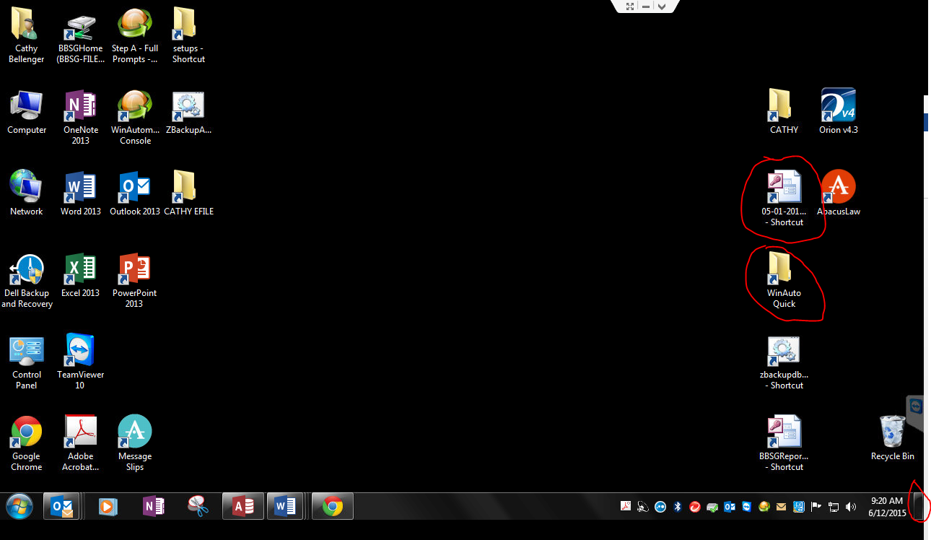

* Right Click on WinAutoQuick
* Select Open.
* Right-click the “Step A” program
* Select Open.

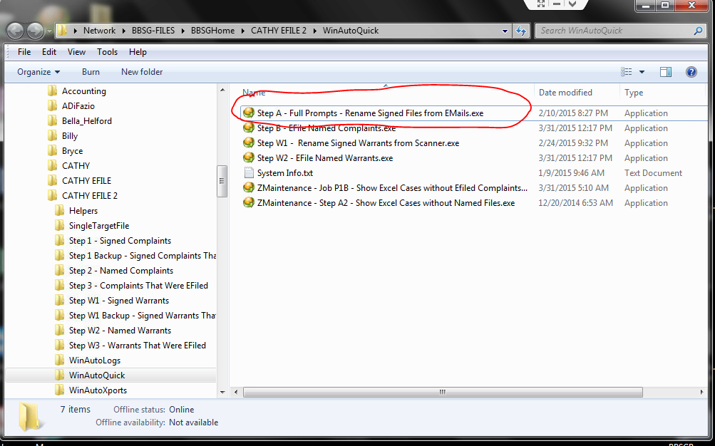

* **Close** the WinAutoQuick Explorer Window that you just opened, since you don’t need it any more. Typically you close a window by using the red X at the top right of the window.

Note that there is a small window in the lower right, with a link to stop this Step W1 job at any time. You can click Stop Job if the process described below “hangs”.

* Click OK on the Rename Signed PDFs Message Box below.

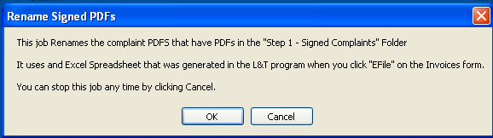

* Enter your name (you must be registered with the system), so that the following file locations are correct. Use “Cathy” on Cathy’s machine.
* Click OK

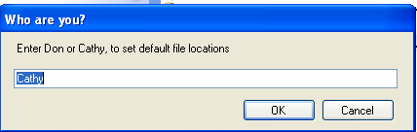

* Click OK to 3 file locations
* Select the Helper Excel File you made in a previous step, e.g. “09.01.2015 14.50.39 Villages at Morgan Metro Complaints Filing 4193 (1).xlsx”. (You will automatically already be in the proper folder: F:\CATHY EFILE2\Helpers)
* WAIT (about 10 seconds)

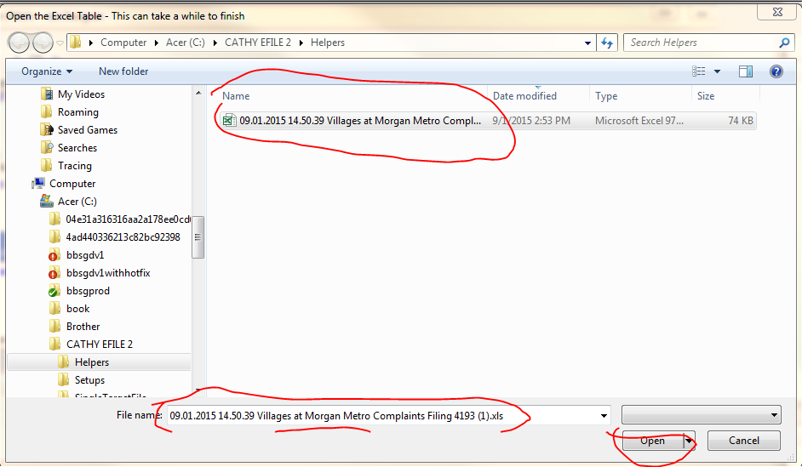

* This Step A routine brings up each case that is in the Excel Helper file.

For each Complaint

* Type in the “Atty Ref” number from the document. It is on the right side of the Complaint under the Property Title. Note: the numbers will not show up in order.
* Click OK. If you type the number incorrectly, you will get a notice. If you type the number correctly, you get a Match! Notice.

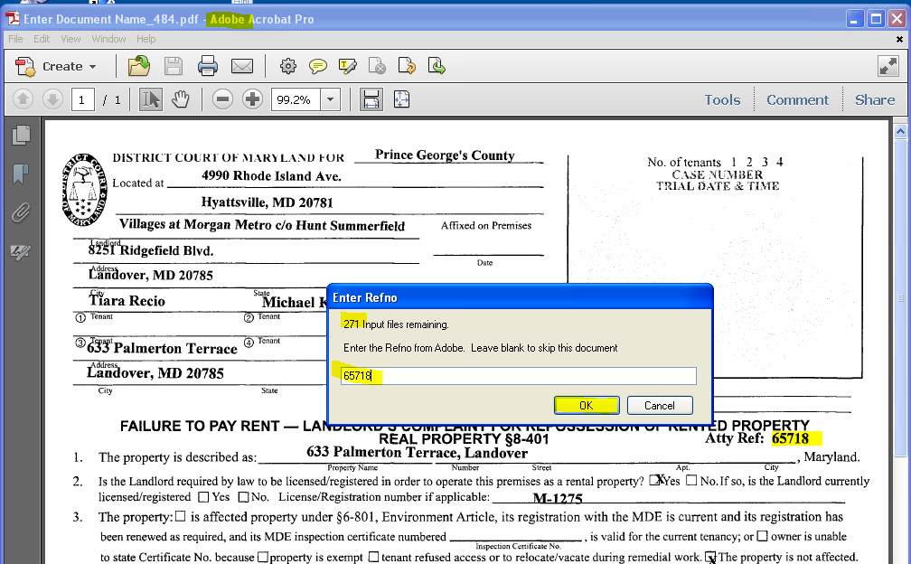

* Verify that the names are the same between the document, and the Match! Message (below), and click Yes.
* If you see a problem, you can click No, and fix things later.
* If things just “hang”,
  + Click “Stop Job” in the small window at the bottom right of your screen.
  + Start again with the steps in this “Step A – Renaming Signed Files” section of this document. You will pick up where you left off.

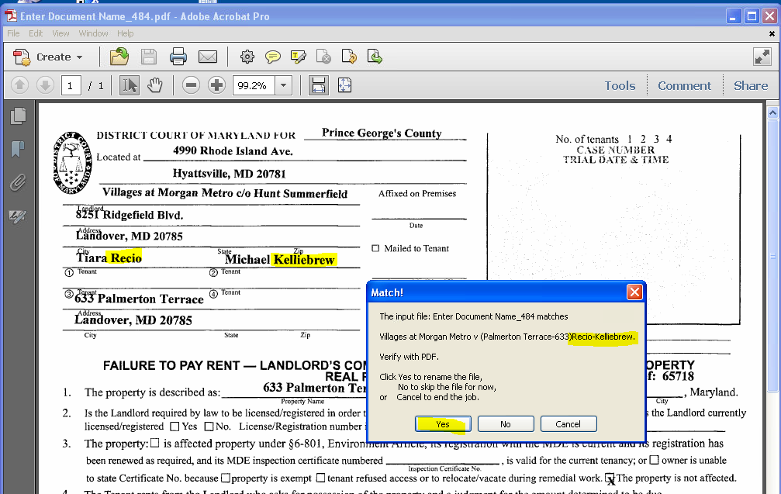

Here is the message you see when one of the signed documents is a duplicate.

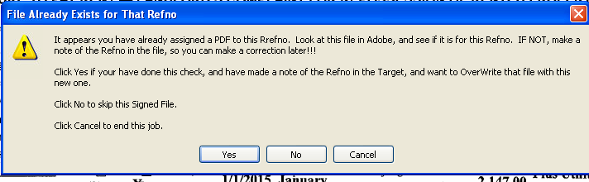

When you have finished renaming the files, you get the completion message.

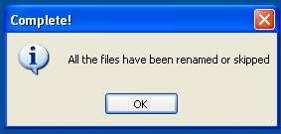

# Connect to EFile Express in the Internet Explorer Web Browser

* If unsure, verify your screen resolution. This will be correct on Cathy’s computer. **This system only runs at 1280 x 720, in Internet Explorer**, because the WinAutomation tool depends on the exact position of various buttons on the web pages.

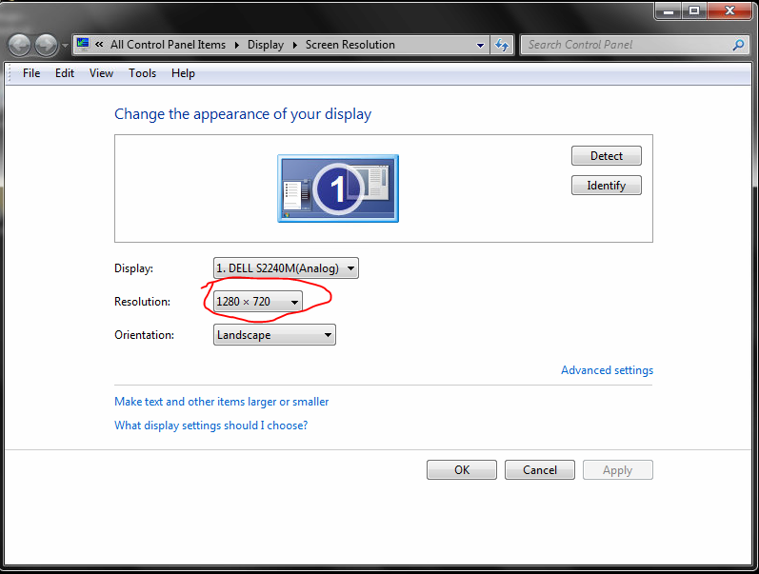

* Start Internet Explorer, which may appear as iexplorer.exe on your Windows Start menu.
* Open the File Express Bookmark (in the Cathy’s folder on her bookmark toolbar), and log in. For reference, the bookmark is <https://secure.fileandservexpress.com/Home/Home.aspx?oldui=true>
* Click on here to log in.

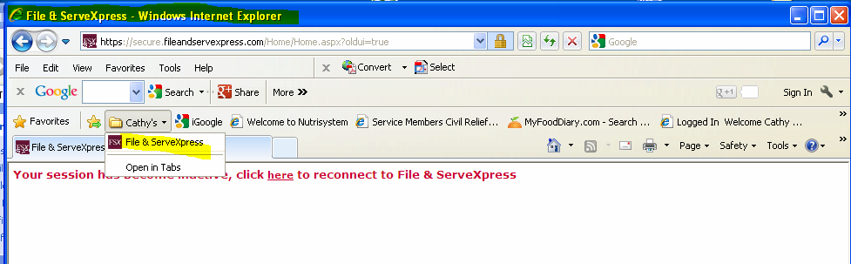

* Click on Filing & Service
* Click on Start A Transaction.
* Make sure this Internet Explorer is Maximized, using button next to the red X on the top right of the window.
* The Internet Explorer window should look exactly as shown below, or else the system may not work. Note there is a tool bar with “Convert” on it, and then the Bookmark Toolbar containing “Cathy’s” below that.

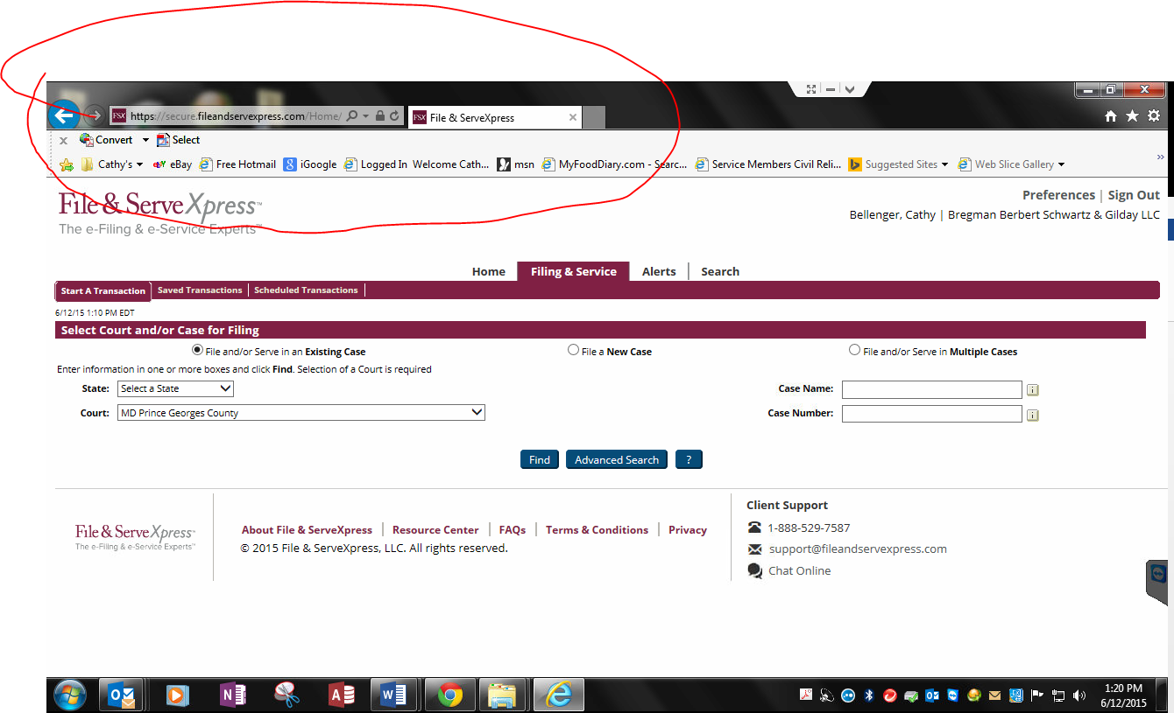

* Leave that window open while you do the next steps.

# Step B – Efile the Named Complaints

* Go to your desktop (see previous instructions about the Windows Desktop button on lower right of your Windows Task Bar).
* Decide what printer you are using, and set it up. If you are using Remote Printing, be sure it is checked in TeamViewer. If you are using a printer locally, be sure it is your “Windows Default Printer”.
* Right-click your desktop on the Shortcut to WinAutoQuick
* Select Open
* Right-click on Step B – Efile Named Complaints.exe
* Select Open.

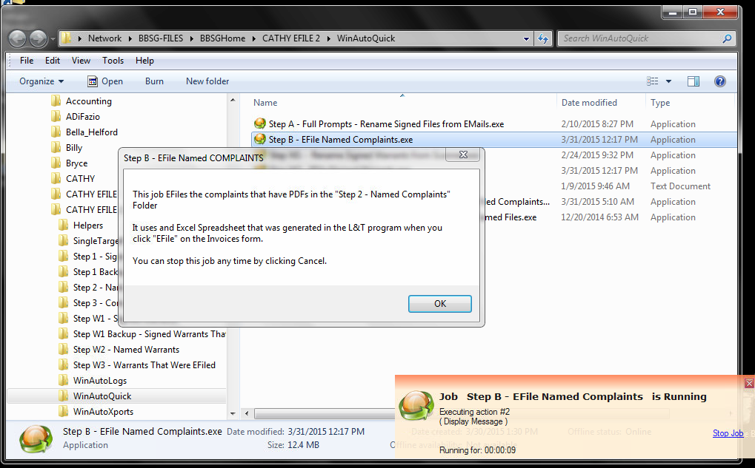

* Note that there is a Small window on the lower right, which contains a link that allows you to stop this “Step B” job at any time. That window will always be there if the job is running.
* Close the larger, WinAutoQuick Window, that shows the various steps (red X on top right of Window)
* Click OK on the button below

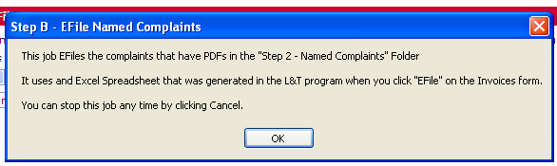

* Enter your name (“Cathy”)
* Click OK
* Click OK 3 times to accept the next three file locations.
* Select the Excel Helper File you made for Step A. Do this by left-clicking it once. You will see the name repeated in the File Name: text box.
* Click Open.



* Edit the date and time for submission. This might typically be at 4 AM or 4:15AM the following day.
* Click OK
* Enter the Plaintiff, properly capitalized. No commas.

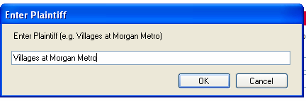

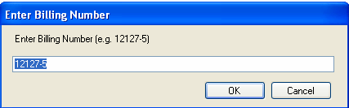x

* Indicate whether you are printing “Remotely” (i.e. at Home). Select this if you are using TeamViewer from home.

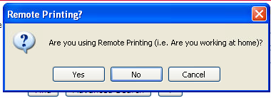

* Select Unattended Processing.
* Minimize (do not Close) the Excel Helper File window.
* Click OK.

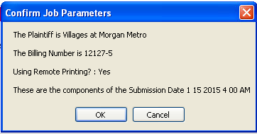

Once you click OK, the Web process starts.

* WAIT (up to 30 seconds)
* Watch Internet Explorer as it processes a Complaint, and continue monitoring as it processes. This procedure is semi-delicate, with many moving parts, and may stop. After each case is filed, a receipt will be printed! The next case will start.
* Monitor the printer for **out of paper**, or **paper jams**.
* **It is very important that you give Cathy the stack of printed receipts from your printer, in order. She uses these to match for case numbers that are returned by the court.**
* Have fun.